# Exercises: Responsive Design

Problems for exercises and homework for the “HTML and CSS” course @ SoftUni. Submit your solutions in the SoftUni judge system at [https://judge.softuni.bg/Contests/412/Responsive-Design](https://judge.softuni.bg/Contests/412/Responsive-Design%20) .

## Responsive CV

You are given an unresponsive Web site (**HTML** + **CSS** + images). Your task is to **make the site responsive**. The site layout should change according to the browser viewport / screen size. You need to implement 4 layouts: **width ≤ 480px**, **481px** **≤ width < 570px**, **571px** **≤ width < 740px** and **width ≥ 740px**:

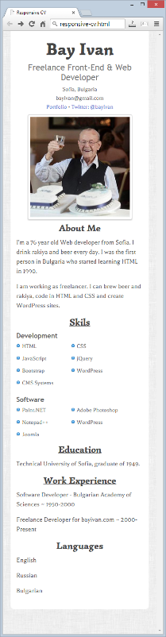 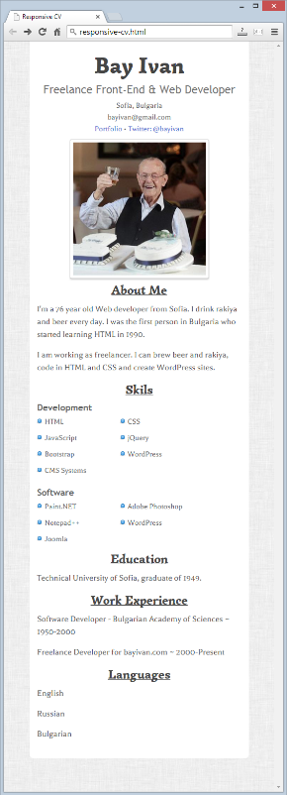 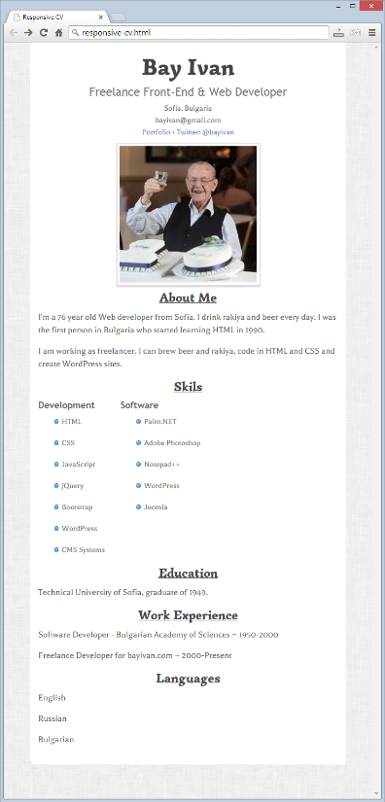 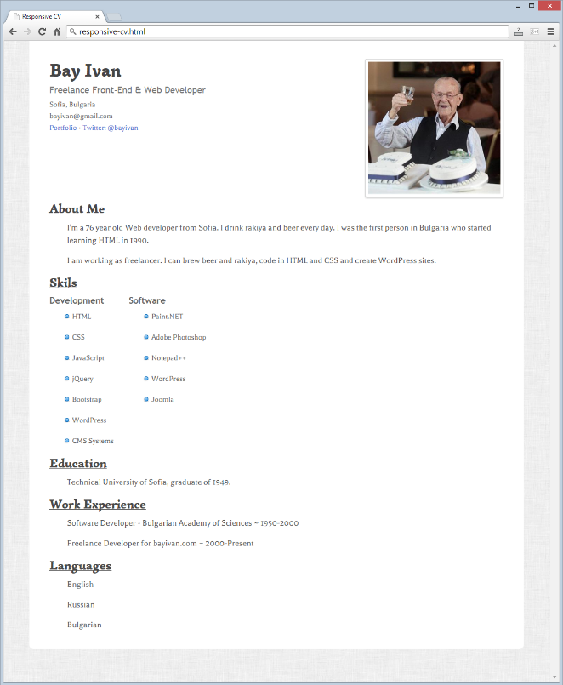

### Steps to Follow

Start with creating file named **responsive.css**:

* @media screen and (max-width: 740px)

#wrapper {  
 Padding: 20px 15px;  
}  
h1 {  
 font-size: 4.5em;  
}  
h3 {  
 font-size: 2.2em;  
}  
h1, h3, h2, small {  
 text-align: center;

}

#photo {

float: none;

width: 100%;

text-align: center;

}

p {

padding: 0;

}

Now test the site in browser.

* @media screen and (max-width: 570px)

ul li {

display: inline-block;

width: 100px;

}

#skills-right ul li:nth-of-type(2) {

width: 140px;

}

* @media screen and (max-width: 480px)

ul li {

padding-left: 16px;

background: url(img/bullet.png) -3px 5px no-repeat;

}

### Input

You are given the unresponsive site as HTML + CSS + images.

### Output

The output should be valid HTML5 + CSS3 + images that implement the above responsive site.

### Constraints

You are free to change the CSS

# * Exam Problems

**All of the problems below are given on Web Fundamentals (HTML & CSS) Practical Exams.**

**You are not obligated** to submit any of them in your homework. We highly recommend you to try solving some or all of them so you can be well prepared for the upcoming exam. If you still find those problems too hard for solving it’s very useful to **check** and **understand** the solutions.

## Unresponsive Web Site

You are given an unresponsive Web site (**HTML** + **CSS** + images). The website is 960px wide and has whitespaces from the left and the right side (see Figure 1). Your task is to **make the site responsive**. The site layout should change according to the browser viewport / screen size.

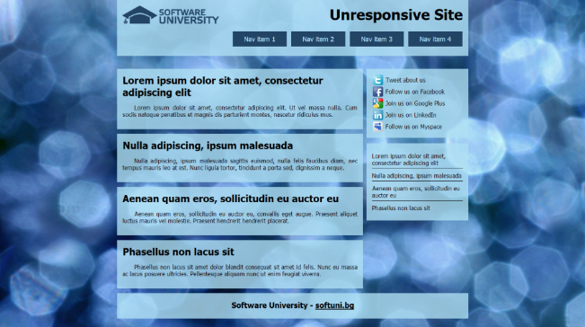 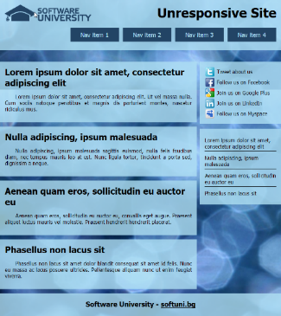

Figure 1

Figure 2

1. From **780px to 960px** – whitespaces disappear, the articles and sidebars scale proportionally with the browser window (see Figure 2).
2. From **640px to 780px** – the menu becomes centered and the menu items are distributed evenly in the entire header (see Figure 3).

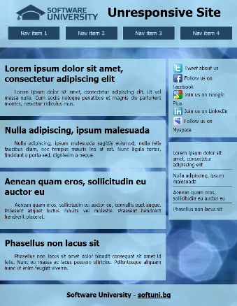 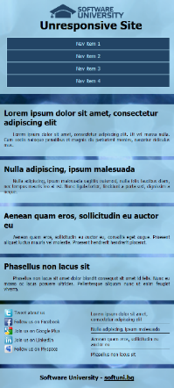 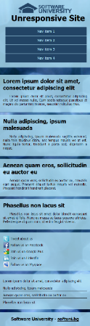

Figure 5

Figure 4

Figure 3

1. From **480px to 640px** – the menu changes again. The sidebars move to the bottom of the page side by side. The header falls under the logo and they are centered (Figure 4).
2. **Under 480px** – the second sidebar falls after the first one (Figure 5).

### Input

You are given the unresponsive site as HTML + CSS + images.

**Output**

The output should be valid HTML5 + CSS3 + images that implement the above responsive site.

### Constraints

You are free to change the CSS

## The Mandarin Bird

You are given an unresponsive Web site (**HTML** + **CSS** + images). Your task is to **make the site responsive**. The site layout should change according to the browser viewport / screen size. You need to implement 2 layouts:

**1200px >=** **width > 730px** , **730px >=** **width >= 500px**. The figures below represent these 3 layouts:

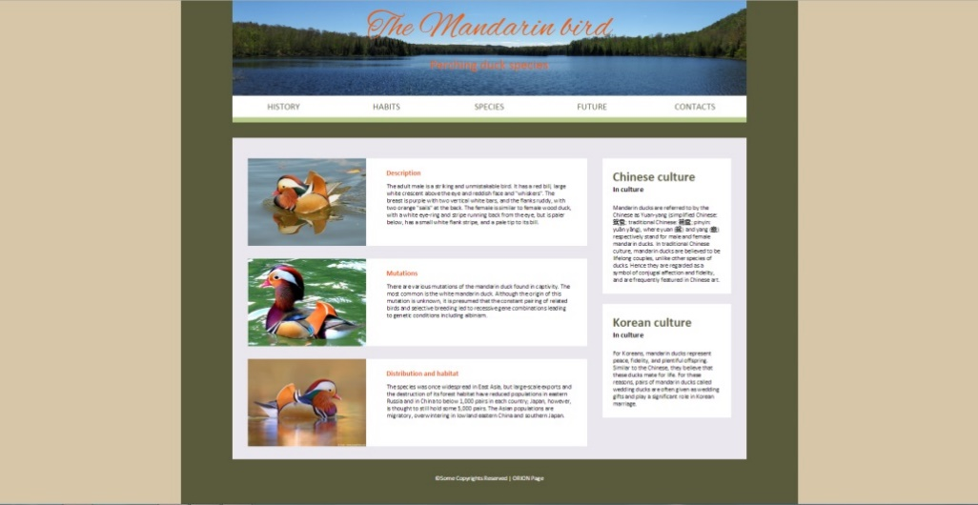 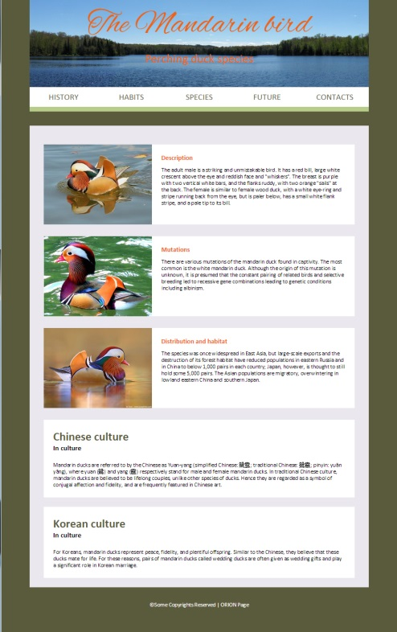 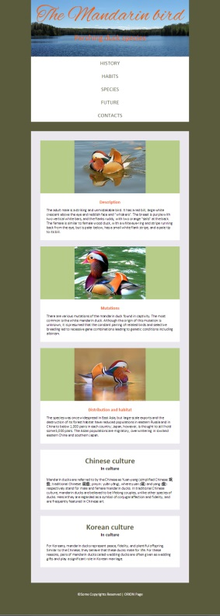

### Input

You are given the unresponsive site as HTML + CSS + images.

### Output

The output should be valid HTML5 + CSS3 + images that implement the above responsive site.

### Constraints

You are free to change the CSS.

## Product Page

You are given an unresponsive Web site (**HTML** + **CSS** + images). Your task is to **make the site responsive**. The site layout should change according to the browser viewport / screen size. You need to implement 1 layout: **width < 640px**.

|  |  |
| --- | --- |
|  | H:\SoftUni\Assisstant\2015\May2015\WebExam12052015\Resources\Problem-4-Unresponsive-Product-Page\04-Preview-Responsive-Hover.jpg |
| Input You are given the unresponsive site as HTML + CSS + images. Output The output should be valid HTML5 + CSS3 + images that implement the above responsive site. Constraints You are free to change the CSS. |

## Responsive Cars

You are given an unresponsive Web site (**HTML** + **CSS** + images). Your task is to **make the site responsive**. The site layout should change according to the browser viewport / screen size. You need to implement 2 layouts: **980px >** **width > 465px** , **width <= 465px**. The figures below represent these 3 layouts:



### Input

You are given the unresponsive site as HTML + CSS + images.

### Output

The output should be valid HTML5 + CSS3 + images that implement the above responsive site.

### Constraints

You are free to change the CSS.

## Planets

You are given an unresponsive Web site (**HTML** + **CSS** + images). Your task is to **make the site responsive**. The site layout should change according to the browser viewport / screen size. You need to implement two additional layouts: **width < 756px**, **756px ≤ width < 1000px**. The figures below represent these two layouts + the unresponsive layout:

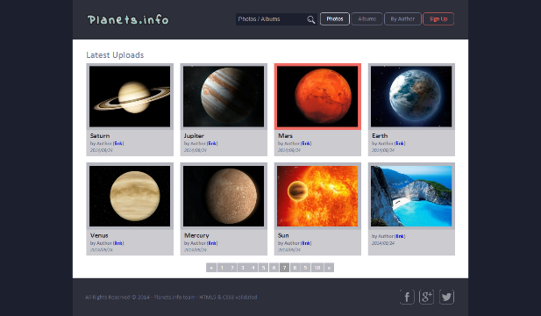 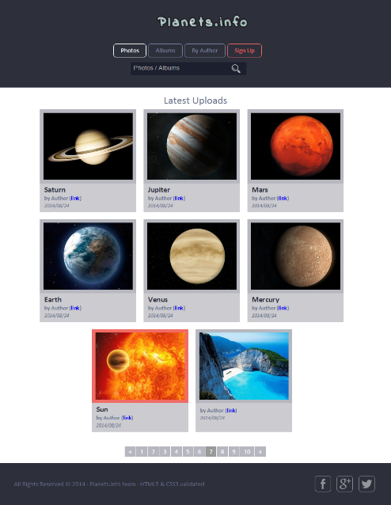 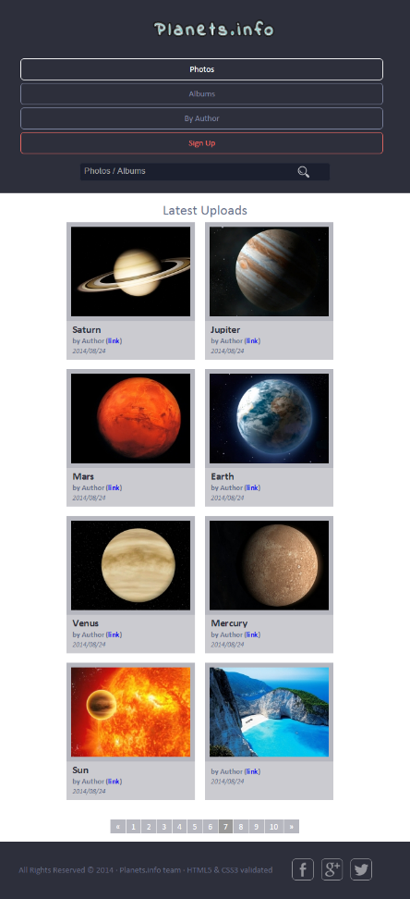

### Input

You are given the unresponsive site as HTML + CSS + images.

### Output

The output should be valid HTML5 + CSS3 + images that implement the above responsive site.

### Constraints

You are free to change the CSS

## Communication Company

You are given an unresponsive Web site (**HTML** + **CSS** + images). Your task is to **make the site responsive**. The site layout should change according to the browser viewport / screen size. You need to implement 2 layouts:

(**width < 700px)** and **(700px < width < 1200px)**. The figures below represent these 3 layouts:

|  |  |
| --- | --- |
|  |  |

### Input

You are given the unresponsive site as HTML + CSS + images.

### Output

The output should be valid HTML5 + CSS3 + images that implement the above responsive site.

### Constraints

You are free to change the CSS

### Examples

Current: <https://invis.io/R38PWNYVP#/191484429_04-Preview-Responsive>

To do (under 1200px): <https://invis.io/R38PWNYVP#/191484432_04-Preview-Responsive-Under1200px>

To do (under 700px): <https://invis.io/R38PWNYVP#/191484431_04-Preview-Responsive-Under700px>